1. **Execute all the join with examples.**

What is Join?

Join is used to combine rows of two or more tables based on the relation based on the relation column between them.

They are totally 6 joins in SQL, namely:

* INNER Join
* LEFT Join
* RIGHT Join
* FULL Join
* CROSS Join
* SELF Join

For the above context, I will take a simple example to explain all the types of joins. Initially I will create a database name “**coding_challenge_01**” by using a command called ‘CREATE DATABASE coding_challenge_01’.

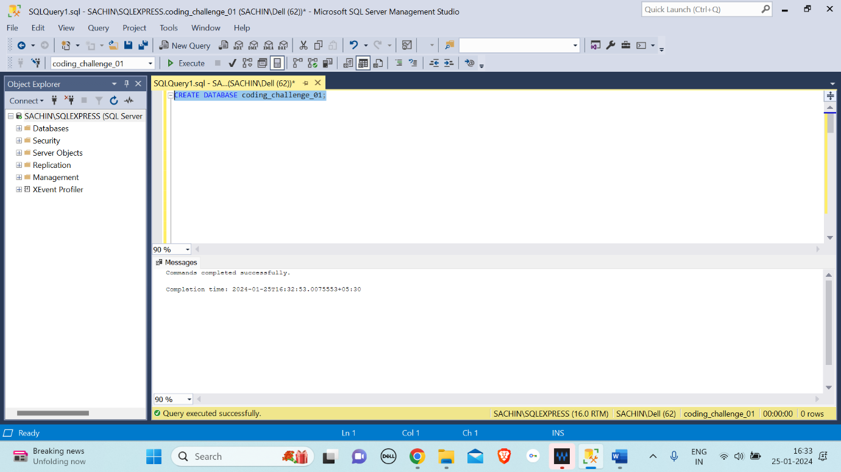

Then I will type a command to use the database ‘USE coding_challlenge_01’.

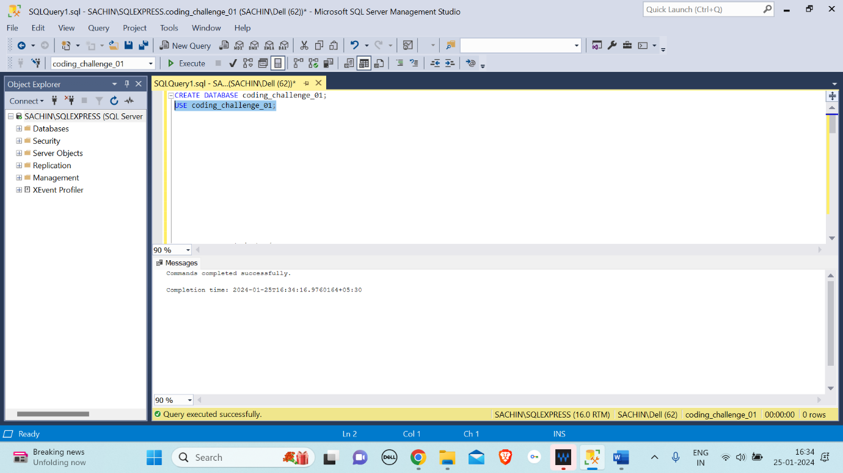

After creating and using the database to store and perform all the operations I will create table namely students and courses as shown below:

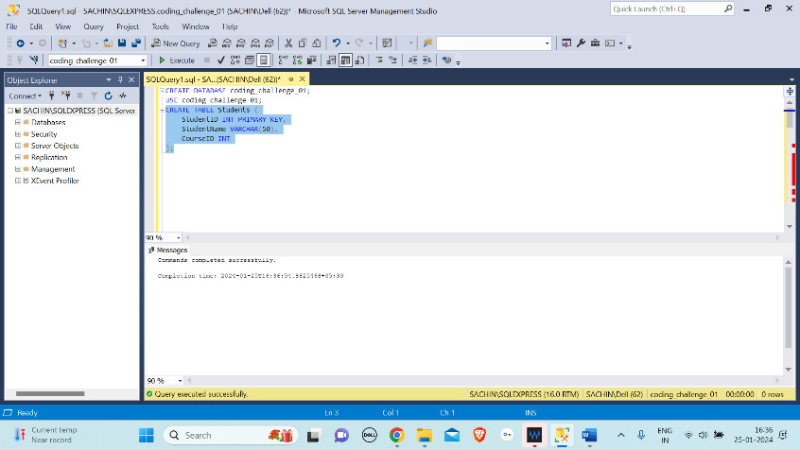

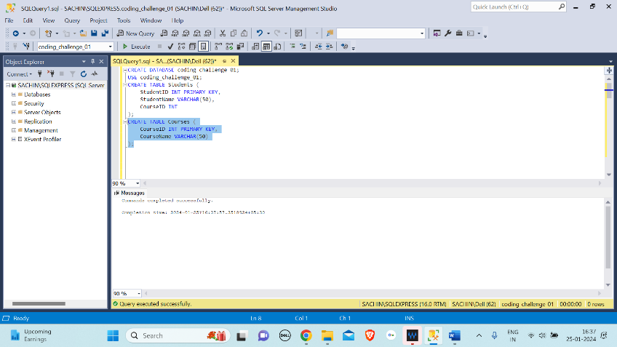

After creating the table insert the vales to Students and Courses tables as shown below:

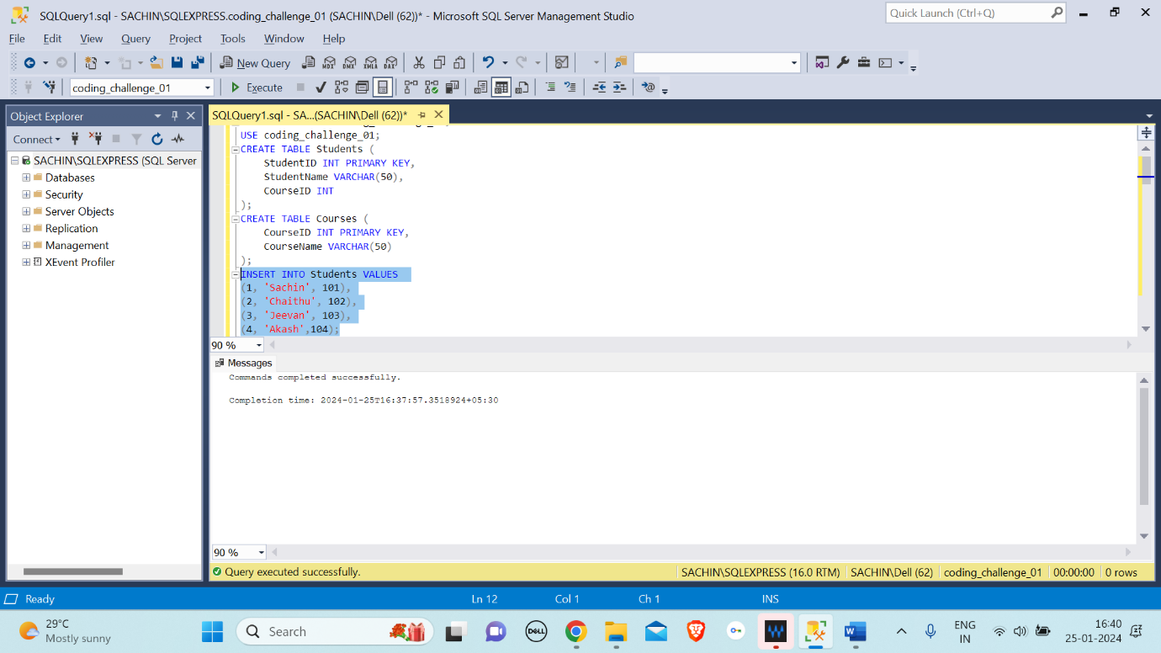

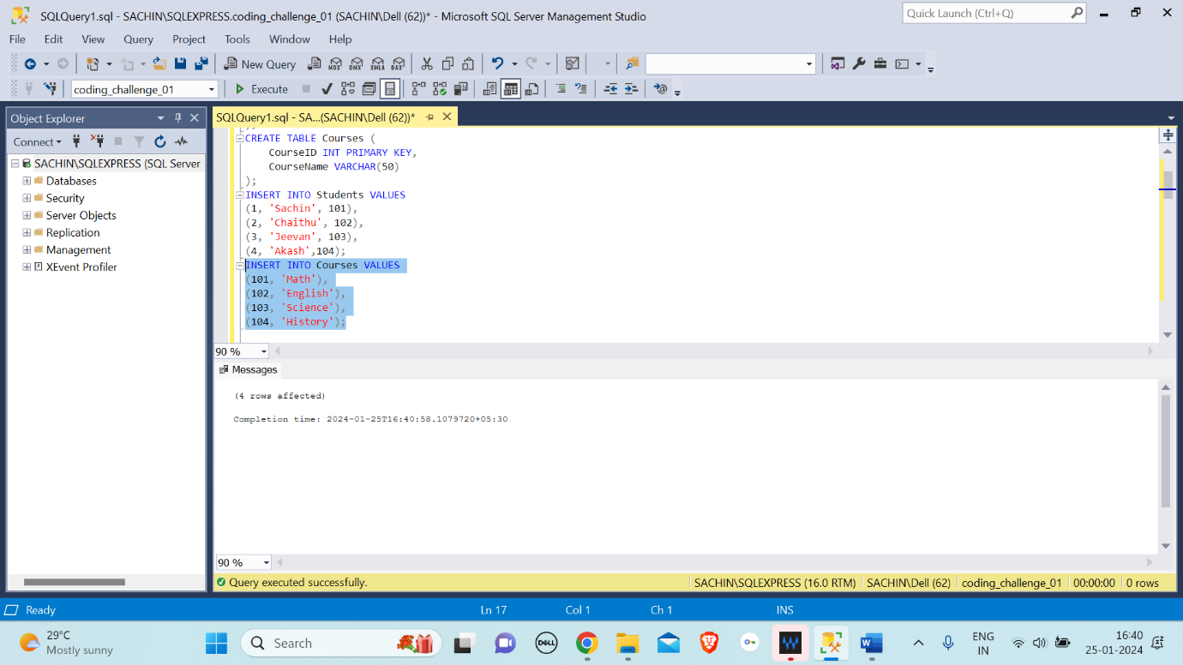

From here on-wards, we will start to understand the different types of Joins by taking the above created database and values.

INNER JOIN: The inner join is a type of a join that combines tables and takes the common values from the tables. Example:

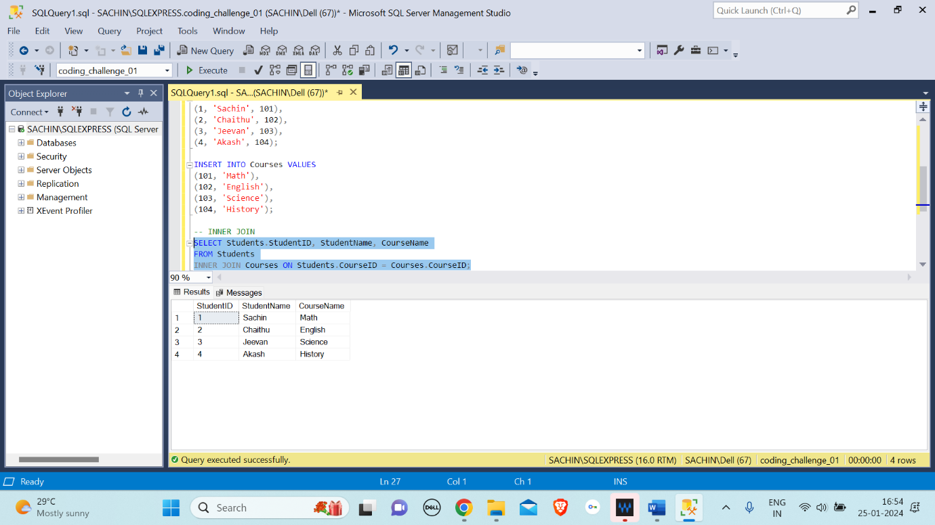

The above query returns rows where there are matching ‘CourseID’ values in both the ‘Students’ and ‘Courses’ tables.

LEFT JOIN: The left join is a type of join where it returns all the values from the left table (here that is student table) and the common values from the right table(here that is Courses table). Example:

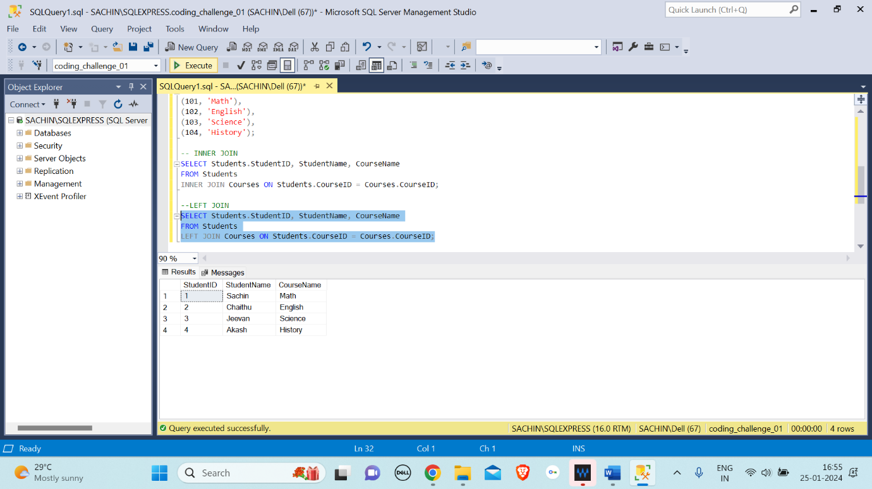

Thie above query returns all students, and if there's a matching ‘CourseID’ in the ‘Courses’ table, it includes the ‘CourseName’. If there's no match, the ‘CourseName’ is NULL.

RIGHT JOIN: The right join is a type of join where it returns all the value from the right table (here that is courses table) and the common values from left table (here that is students table). Example:

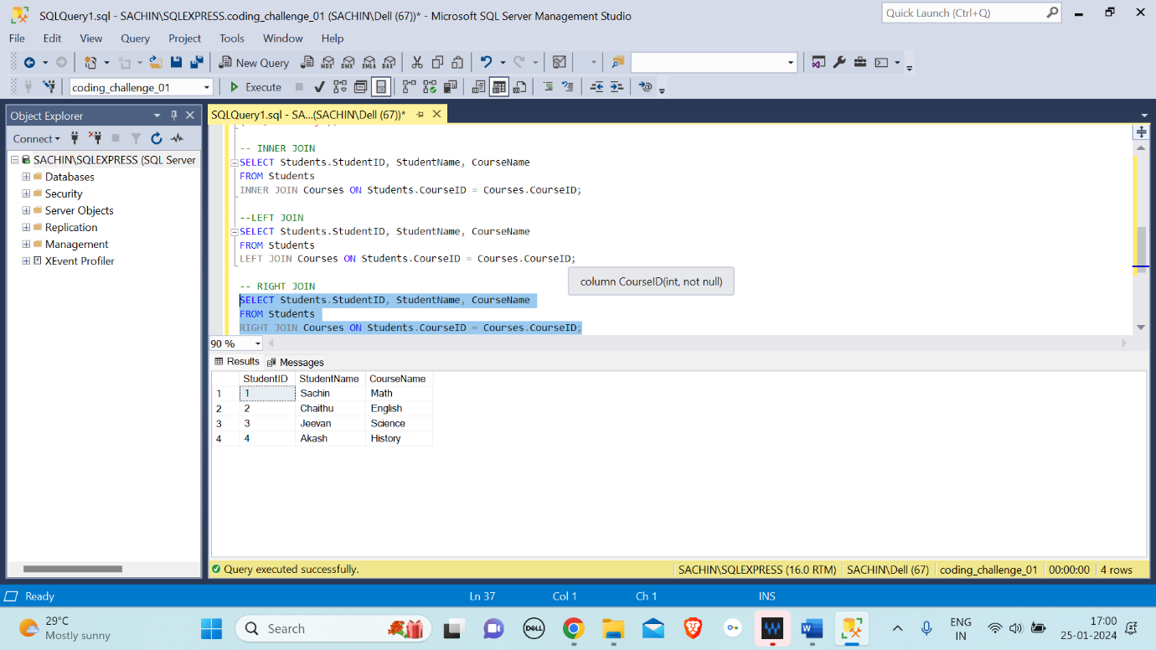

The above query returns all courses, and if there's a matching ‘CourseID’ in the ‘Students’ table, it includes the ‘StudentName’. If there's no match, the ‘StudentName’ is NULL

FULL OUTER JOIN/ FULL JOIN: This type of join will return the values from the both side of left and right tables (Here that is the vales of both students and courses table.) Example:

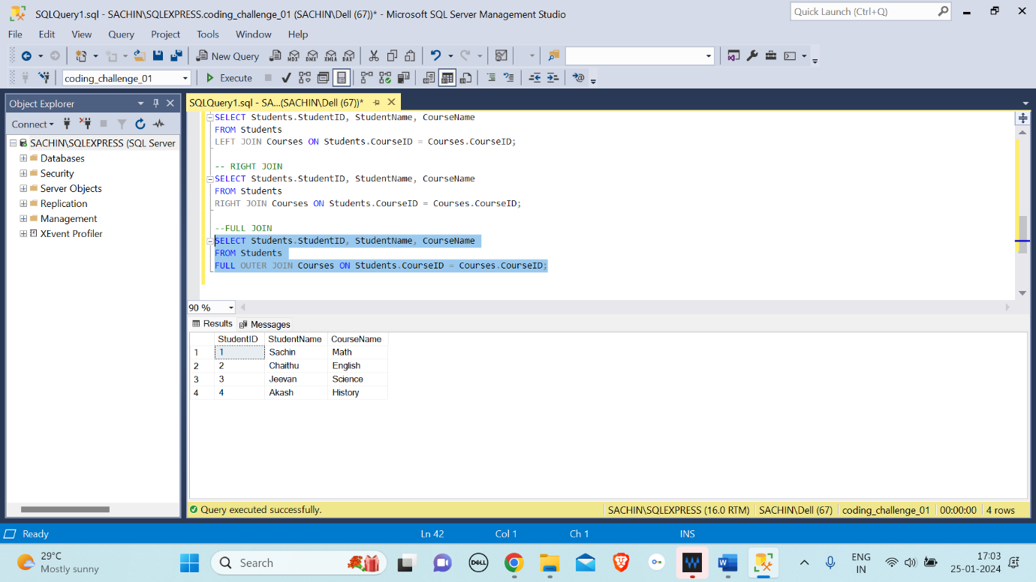

The above query returns all students and courses.

CROSS JOIN: this type of joins returns cartesian product of the two tables. Example:

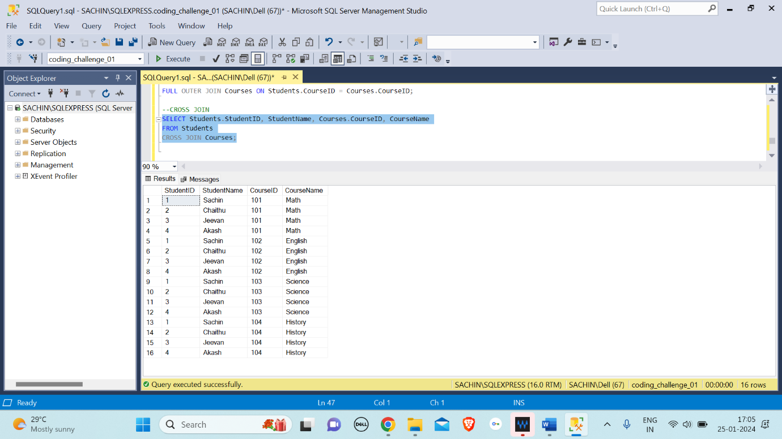

The above query returns all possible combinations of students and courses.

SELF JOIN: This type of join is used when a table is joined with itself.

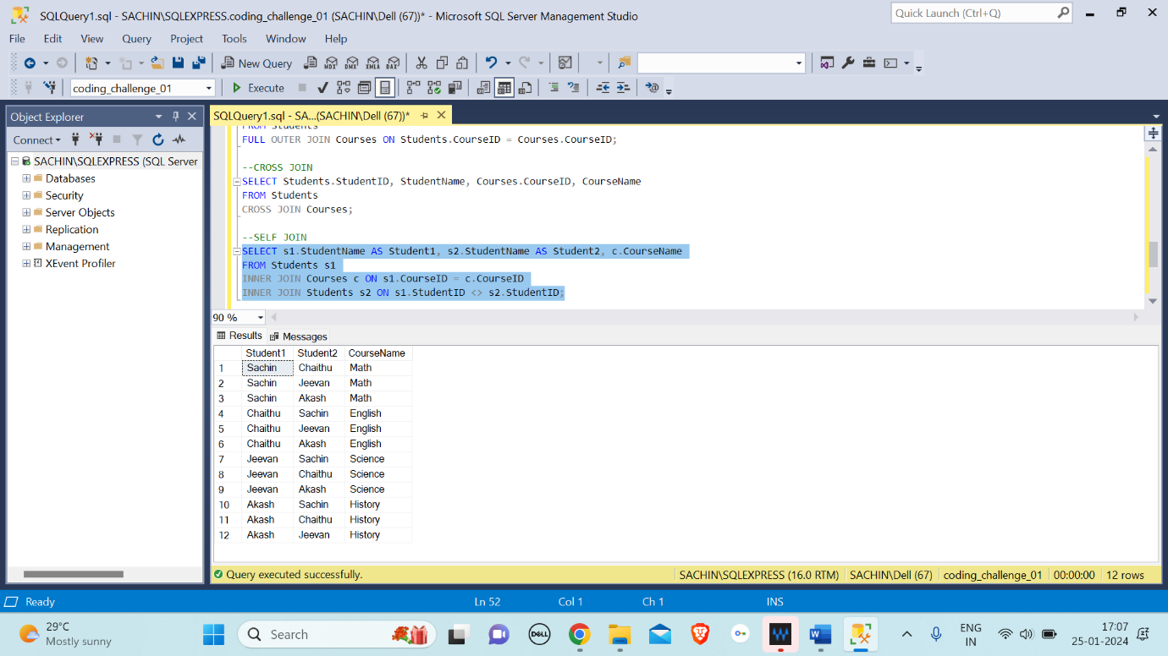

The above query finds pairs of students who are enrolled in the same course, excluding the student itself.